BCSE497J - PROJECT-I

EXPLAINABLE MULTIMODAL AI FOR EARLY DETECTION OF LEARNING ENGAGEMENT AND EMOTIONAL STATES IN CHILDREN USING EYE MOVEMENT

23BCE2012 | ILAKKIYA S
23BCE2064 | ADHVAITH N A
23BDS0006 | DON GEORGE

Under the Supervision of
Prof. DEEPIKA J
Assistant Professor Senior Grade 1
School of Computer Science and Engineering

B.Tech.
in
Computer Science and Engineering

School of Computer Science and Engineering



October 2026
ABSTRACT
Learner engagement detection based on the analysis of webcam video stream is quite challenging because of the inefficiency of the classifier and unreliability of the data. The user turns away from the webcam, the hand touches the cheek, or the webcam gets out of focus – and there is an unseen face which should be used to predict an emotion. Most of the systems tend to skip such frames, thereby solving the problem of unreliable data but destroying the time sequence.
In this paper, we design a reliability-based pipeline for the DAiSEE dataset where there is no discarding of the frames, but rather weighting. The Motion Reliability Score (MRS) for every frame is computed using the five observation quality metrics: blur, face visibility, head pose, eye and iris visibility, and motion consistency - none of which depend on the engagement label. For each aligned face crop, a 768-dimensional embedding is extracted using the ImageNet pretrained frozen Vision Transformer; the reliability score is used to weight the embedding and the temporal pooling step, such that unreliable frames are not more influential in the process while being retained in the sequence. The Mamba selective state-space model reads the weighted sequence over time. There is also a MediaPipe pipeline that provides 28 normalized geometric features and 52 ARKit blendshapes per frame.
Rather than arbitrarily fixing the weights of the five MRS units to any random value, the system is able to adaptively learn how to change those weights depending on the values it learns during its training phase per epoch. The weight starts at 0.20 per unit and is trained using the gradient descent algorithm. The system is able to get 38.75% validation accuracy as compared to 25% by chance (binomial p = 0.0046).

Keywords - Student Engagement Recognition, Vision Transformer, Mamba State-Space Model, Observation Reliability, MediaPipe Face Landmarks, DAiSEE, Explainable AI.
DECLARATION

We hereby declare that the project entitled "EXPLAINABLE MULTIMODAL AI FOR EARLY DETECTION OF LEARNING ENGAGEMENT AND EMOTIONAL STATES IN CHILDREN USING EYE MOVEMENT" submitted by us, for the award of the degree of Bachelor of Technology in Computer Science and Engineering to VIT is a record of bonafide work carried out by us under the supervision of Prof. Deepika J.
We further declare that the work reported in this project has not been submitted and will not be submitted, either in part or in full, for the award of any other degree or diploma in this institute or any other institute or university.

Place: Vellore
Date:

Signature of the Candidates
ILAKKIYA S (23BCE2012)
ADHVAITH N A (23BCE2064)
DON GEORGE (23BDS0006)
CERTIFICATE
This is to certify that the project entitled "EXPLAINABLE MULTIMODAL AI FOR EARLY DETECTION OF LEARNING ENGAGEMENT AND EMOTIONAL STATES IN CHILDREN USING EYE MOVEMENT" submitted by ILAKKIYA S (23BCE2012), ADHVAITH N A (23BCE2064) and DON GEORGE (23BDS0006), School of Computer Science and Engineering, VIT, for the award of the degree of Bachelor of Technology in Computer Science and Engineering, is a record of bonafide work carried out by them under my supervision during Fall Semester 2026-2027, as per the VIT code of academic and research ethics.
The contents of this report have not been submitted and will not be submitted either in part or in full, for the award of any other degree or diploma in this institute or any other institute or university. The project fulfills the requirements and regulations of the University and in my opinion meets the necessary standards for submission.

Place: Vellore
Date:

Signature of the Guide
Prof. Deepika J

Examiner(s)

<< Head of the Department >>
Computer Science and Engineering
ACKNOWLEDGEMENTS

We are deeply grateful to the management of Vellore Institute of Technology (VIT) for providing us with the opportunity and resources to undertake this project. Their commitment to fostering a conducive learning environment has been instrumental in our academic journey. The support and infrastructure provided by VIT have enabled us to explore and develop our ideas to their fullest potential.
Our sincere thanks to Dr. Jaisankar N, the Dean of the School of Computer Science and Engineering (SCOPE), for his unwavering support and encouragement. His leadership and vision have greatly inspired us to strive for excellence, and his dedication to academic excellence and innovation has been a constant source of motivation.
We express our profound appreciation to << Head of the Department >>, the Head of the Department, for insightful guidance and continuous support. That expertise and advice have been crucial in shaping the direction of our project, and the commitment to a collaborative and supportive atmosphere has greatly enhanced our learning experience.
We are immensely thankful to our project guide, Prof. Deepika J, for her dedicated mentorship and invaluable feedback. Her patience, knowledge and encouragement have been pivotal in the successful completion of this project. Her willingness to share her expertise and provide thoughtful guidance has been instrumental in refining our ideas and methodology, and has enriched our overall academic experience.
Thank you all for your contributions and support.

ILAKKIYA S
ADHVAITH N A
DON GEORGE

TABLE OF CONTENTS
Sl.No | Contents | Page No.
 | Abstract | i
1. | INTRODUCTION | 1
 | 1.1 Background | 1
 | 1.2 Motivations | 1
 | 1.3 Scope of the Project | 1
2. | PROJECT DESCRIPTION AND GOALS | 2
 | 2.1 Literature Review | 2
 | 2.2 Research Gap | 4
 | 2.3 Objectives | 4
 | 2.4 Problem Statement | 5
 | 2.5 Project Plan | 5
3. | TECHNICAL SPECIFICATION | 6
 | 3.1 Requirements | 6
 | 3.1.1 Functional | 6
 | 3.1.2 Non-Functional | 7
 | 3.2 Feasibility Study | 8
 | 3.2.1 Technical Feasibility | 8
 | 3.2.2 Economic Feasibility | 9
 | 3.2.3 Social Feasibility | 9
 | 3.3 System Specification | 9
 | 3.3.1 Hardware Specification | 9
 | 3.3.2 Software Specification | 10
4. | DESIGN APPROACH AND DETAILS | 10
 | 4.1 System Architecture | 11
 | 4.2 Design | 13
 | 4.2.1 Data Flow Diagram | 13
 | 4.2.2 Use Case Diagram | 14
 | 4.2.3 Class Diagram | 15
 | 4.2.4 Sequence Diagram | 16
5. | METHODOLOGY AND TESTING | 17
 | 5.1 Module Description | 17
 | 5.2 Testing | 18
6. | PROJECT DEMONSTRATION | 20
 | 6.1 Execution Sequence | 20
 | 6.2 Stage Outputs | 20
 | 6.3 Inference on a Single Clip | 20
 | 6.4 Explanation Output | 21
7. | RESULT AND DISCUSSION | 23
 | 7.1 Experimental Protocol | 23
 | 7.2 Three-Class Engagement Recognition | 23
 | 7.3 Binary Disengagement Detection | 24
 | 7.4 Ablation: Does Reliability Weighting Contribute? | 24
 | 7.5 Reliability Weight Stability | 25
 | 7.6 Explainability Results | 26
 | 7.7 Discussion | 27
8. | CONCLUSION | 27
 | 8.1 Summary of Work | 28
 | 8.2 Findings | 28
 | 8.3 Limitations | 28
 | 8.4 Future Work | 29
 | 8.5 Closing Remark | 29
9. | REFERENCES | 29
 | APPENDIX A - SAMPLE CODE | 32

LIST OF FIGURES

Figure No. | Title | Page No.
Figure 2.1 | Gantt chart for Project-I schedule | 6
Figure 4.1 | System architecture of the MRG-ViT-Mamba engagement recognition pipeline | 11
Figure 4.2 | Level-0 data flow diagram for engagement inference on a single clip | 13
Figure 4.3 | Use case diagram | 14
Figure 4.4 | Class diagram of the developed system | 15
Figure 4.5 | Sequence diagram for engagement inference on one clip | 16
Figure 6.1 | SHAP attribution by facial feature family, 512 test clips | 21
Figure 6.2 | Confusion matrix on the full DAiSEE test split, 1,784 clips | 21
Figure 7.1 | Top named landmark features by mean absolute SHAP value | 27
LIST OF TABLES

Table No. | Title | Page No.
Table 3.1 | Hardware specification | 9
Table 3.2 | Software specification | 10
Table 4.1 | Parameter budget of the assembled model | 12
Table 5.1 | Automated test coverage by concern | 19
Table 6.1 | Pipeline stages, outputs and measured cost | 20
Table 7.1 | Three-class results on the full DAiSEE test split (1,784 clips) | 23
Table 7.2 | Performance for each class in three-class classification test data | 23
Table 7.3 | Binary detection results on the full DAiSEE test split | 24
Table 7.4 | Ablation study in the complete DAiSEE split | 25
Table 7.5 | Simulated maximum component weight after a full run | 25
Table 7.6 | SHAP attribution by feature group, 512 test clips | 26
LIST OF ABBREVIATIONS

Abbreviation | Expansion
API | Application Programming Interface
AU | Action Unit
AUC | Area Under the Curve
CNN | Convolutional Neural Network
CPU | Central Processing Unit
CSV | Comma-Separated Values
DAiSEE | Dataset for Affective States in E-Environments
F1 | F1 Score, the harmonic mean of precision and recall
GELU | Gaussian Error Linear Unit
GPU | Graphics Processing Unit
LSTM | Long Short-Term Memory
MLP | Multilayer Perceptron
MRS | Motion Reliability Score
RAM | Random Access Memory
RMSNorm | Root Mean Square Normalisation
ROC | Receiver Operating Characteristic
SHAP | SHapley Additive exPlanations
SiLU | Sigmoid Linear Unit
ViT | Vision Transformer
SYMBOLS AND NOTATIONS

Symbol | Meaning
T | Number of frames sampled from each clip
N | Number of frames decoded from the source video
t | Index of a sampled frame, 1 to T
r_t | Motion reliability score of frame t, in [0,1]
f_t | Vision Transformer embedding of frame t
f'_t | Reliability-weighted frame embedding, f'_t = r_t f_t
h_t | Temporal encoder output at position t
D | Clip representation after reliability-weighted pooling
w | Weight vector over the five reliability components
C | Number of engagement classes

1. INTRODUCTION

1.1 Background

Of the many ways to measure learning outcomes, engagement is one of the most accurate ones. Engagement measurement has gained great importance recently due to classes moving to the online mode. While in an ordinary classroom setting the professor continuously monitors the learners' reactions, in an online class held through video cameras, this loop has been broken. Automatic engagement detection from webcam video is aimed at restoring it.

This task uses the DAiSEE benchmark dataset. The dataset contains 9,068 videos of 10 seconds duration each taken from 112 participants from unrestricted environments, dorms, labs, and offices and is categorized in four affective states, boredom, confusion, engagement, and frustration, into four levels of intensity. In this project, only engagement labels are considered.

Engagement detection is distinguished from regular facial expression detection because engagement is a temporal construct. Engagement cannot be detected by a snapshot, but can be observed through the focused attention and steady body posture of the person over a number of seconds. The algorithm needs to be capable of analyzing a series of frames rather than an image alone. Recent state space modeling techniques such as Mamba make this possible.

1.2 Motivation
The motivation behind this project is one specific drawback of existing pipelines: uniform trust towards all frames. Live cam recordings are not equal in terms of observability. Someone goes out of the frame, someone hides the face with their hand, the camera cannot focus well, the environment is too dark. Poor quality frame implies poor quality visual features for classification – and thus noise in the prediction.
The common practice is to use gating and discard frames of bad quality, but this is precisely what must not be done in a temporal model: by dropping frames, we change the amount of frames, erase gaps, and remove evenly spaced nature of data, which gives the temporal information. Thus, an occluded recording and a clear recording come into the sequence model in different sizes, and the model will not know which of them is incomplete.
The reason for conducting this research project stems from the use of the same signal but through a different process of treatment. Reliability should be treated as a soft weight rather than as a hard gate, which deletes data. In this regard, every sampled frame retains its position and timing regardless of whether it is reliable or unreliable.

1.3 Scope of the Project
This pipeline encompasses all stages from unprocessed DAiSEE videos to engagement prediction with four classes and their explanations. Scope: temporal uniform sampling, face detection, alignment, and cropping; computation of a five-dimensional Motion Reliability Score; extraction of frozen Vision Transformer features; reliability-driven temporal modeling with Mamba selective state-space model; MediaPipe geometric and behavior feature extraction pipeline in parallel; features concatenation and classification with SHAP attributions.
Engagement is the only target prediction class. Although boredom, confusion, and frustration classes are present in the dataset, they are not addressed in this pipeline. Frozen Vision Transformer backbone will be applied in all experiments and end-to-end fine-tuning will be performed after validating the pipeline. The dataset will be evaluated based on the DAiSEE partition and the subject disjointness will be verified.
The current work does not claim that this project aims at beating the highest accuracy achieved by DAiSEE before. The problem statement is whether reliability guided temporal modeling will improve robustness while preserving temporal information in it. The objective is to create and verify the pipeline, but not publish anything without considering its nature.

2. PROJECT DESCRIPTION AND GOALS

2.1 Literature Review

The review of literature can be classified into five classes: the data set and the benchmark, temporal structures in videos, state space modeling for sequences, facial feature extraction, and quality of observation.

Dataset and benchmark

The DAiSEE was introduced by Gupta et al. [1] as the first large-scale dataset to recognize the affective states in e-learning with unconstrained webcam videos, establishing the benchmark in terms of a four-state, four-level annotation framework. The benchmark difficulty level was set by their baseline approaches that used frame-based features of InceptionNet, C3D and LRCN. Many studies have confirmed the fact that the DAiSEE engagement is extremely unbalanced, since there are majority classes of the two middle levels, and hence accuracy is not enough as a measure of performance [2], [3].

Temporal modelling for engagement
Given the temporal nature of the process, the majority of approaches to this problem assume sequences of frames rather than individual frames as inputs. There exist recurrent approaches to this task with LSTM on top of frame-wise CNN features [4], 3D convolution-based approaches that learn spatio-temporal filters [5], and more recent approaches based on video transformers utilizing self-attention across the frames [6]. Although attention-based architectures outperform recurrent ones, they operate in O(n²), where n is the number of frames.

State-space sequence models
Mamba was proposed by Gu and Dao [7], a selective state-space model where the model parameters are functions of the input, allowing content-dependent information propagation along the sequence in linear time and constant inference memory. In a follow-up work, Zhu et al. [8] extended the concept to the vision domain as Vision Mamba (Vim), with the application of bidirectional Mamba blocks on image patches tokens as a backbone. It is necessary to make a distinction between these two applications; Vim is a spatial backbone on image tokens, while the use of Mamba on a sequence of frame-level embeddings is temporal modeling. The current work performs the latter and is therefore named as such. Variants of Mamba have been used before in the DAiSEE task – a recently proposed multi-scale contrastive framework reports results for Vision Mamba and VMamba baselines on this benchmark [9].

Facial feature extraction
Lugaresi et al. [10] discuss MediaPipe where the Face Mesh model regresses 468 three-dimensional landmarks of a face in real-time using standard hardware, further extending it with the iris refinement to 478 landmarks [11]. Kartynnik et al. [12] provide an overview of mesh regression itself. Besides raw landmarks, the MediaPipe Face Landmarker provides 52 blendshapes activations similar to those used in ARKit in the sense that they include eye blink, brow lower and jaw open among others. Those features are akin to Facial Action Units [13] but extracted without an extra AU model. Since the raw landmarks are strongly biased by the face scale and location, normalised geometric derivatives such as eye aspect ratio [14] are generally preferred.

Observation quality and reliability
There is a long-standing history behind evaluation of image sharpness; variance of the Laplacian [15] is still the classic non-reference estimator despite being prone to contrast-related artifacts, which leads to development of alternative estimators that have better perceptual properties [16]. More specifically, in face analysis, face image quality evaluation helped to predict recognition errors [17], thus proving the ability to use the metric to change recognition confidence. The idea of uncertainty-aware and confidence-weighted fusion is a common approach in multimodal learning [18]; attention-based weighting of video frames worked for face recognition tasks [19]. It is quite unusual to design a pipeline where a quality score that is both understandable and labeling-independent would be calculated, and then it would be used to change temporal model without deleting frames – that is what this project solves.
Explainability
SHAP was proposed by Lundberg and Lee [20]. It is a method of attribution that is built on the basis of the additive property and has a lot of good theoretical characteristics. The method became the standard way to provide explainability for the affective computing models. In this research, attribution is used to understand the dependency of the classifier on facial features.
2.2 Research Gap
Three specific gaps are observed from the above literature review.
- The idea of reliability is considered as a gate, not a weight. In the current frameworks, where quality-aware models are used, there is a threshold put for the quality of the frames. If it is lower than the set value, these frames are ignored. In the case of the temporal model, such an approach is counterproductive since it alters the number of frames in the sequence and thus, violates their uniform spacing in time. There is no pipeline in DAiSEE where the whole sequence remains unbroken and only the frames are weighted.
- The weight values are predefined, not learnt. If several factors participate in defining the quality of the frame, then these factors' weights are also predefined manually, but always equally. The question is whether they carry the equal amount of importance for the particular dataset and camera configuration.
- Confusion exists between reliability and behavior. Shaking one’s head and closing the eyes are seen as signs of disengagement. The confusion arises from mistaking reliability for the construct of interest, because a head shake lessens the strength of front-looking evidence, and blinking is just a natural human behavior, and not poor observation. Reliability that can be affected by labeling does not remain reliable.
2.3 Objectives
This work aims to achieve the following objectives.
• O1. Adopt the validated DAiSEE processing pipeline where the canonical train/validation/test splits remain unmodified and the subject disjointness of the three splits is proven to be 0.
• O2. Define and implement a five-fold Motion Reliability Score in [0,1] based solely on the observation quality data such that each component is well-defined and correctly bounded within the entire corpus.
• O3. Convert the reliability score into a ViT-plus-Mamba temporal model architecture in which the number and order of the temporal frames stay intact – there will be no dropped frames at any time.
• O4. Replace the existing random uniform weight assignment for the reliability components with the one derived through the gradient descent algorithm starting from the initialization value of 0.20 for each component.
• O5. Integrate the MediaPipe geometry and behavior branches with the deep temporal branch using the normalization statistics estimated only on the train split.
• O6. Perform accuracy, weighted F1, macro F1, precision/recall/F1 per class, and confusion matrix calculation, compared with chance and majority class baselines statistically.
• O7. SHAP attribution over the fused representation grouped into the interpretable facial feature families.

2.4 Problem Statement
Determine the engagement class from among the four ordered classes of engagement: Very Low, Low, High, and Very High based on an unlabeled ten-second webcam video clip of a single learner, while accounting for the differences in observation within the clip depending on their different quality without loss of any temporal information.
From the mathematical point of view, each clip contains T evenly sampled frames. The reliability r_t ∈ [0,1] of every frame t is estimated using only the information about observation quality, while the Vision Transformer network is frozen and produces embeddings f_t for every frame t. The goal is to produce a mapping from the reliability-weighted sequence to the four-class classification where both sequence length and order of temporal positions do not depend on the quality of frames.
The problem is further compounded by three characteristics of the data: the labels are highly imbalanced within the full release of DAiSEE; adjacent intensity levels like High and Very High look alike even to humans; and one participant might occur multiple times within the data, so that the model could get good accuracy through learning participants’ identities rather than their engagement.

2.5 Project Plan
The Project-I phase was structured into eleven tasks which were conducted within about sixteen weeks, in such a way that each verification step precedes the task dependent on it. The auditing of the data comes prior to any pre-processing of it; the reliability score is designed and calibrated before including it in the model; and the temporal encoder is verified with respect to an independent implementation prior to its training.

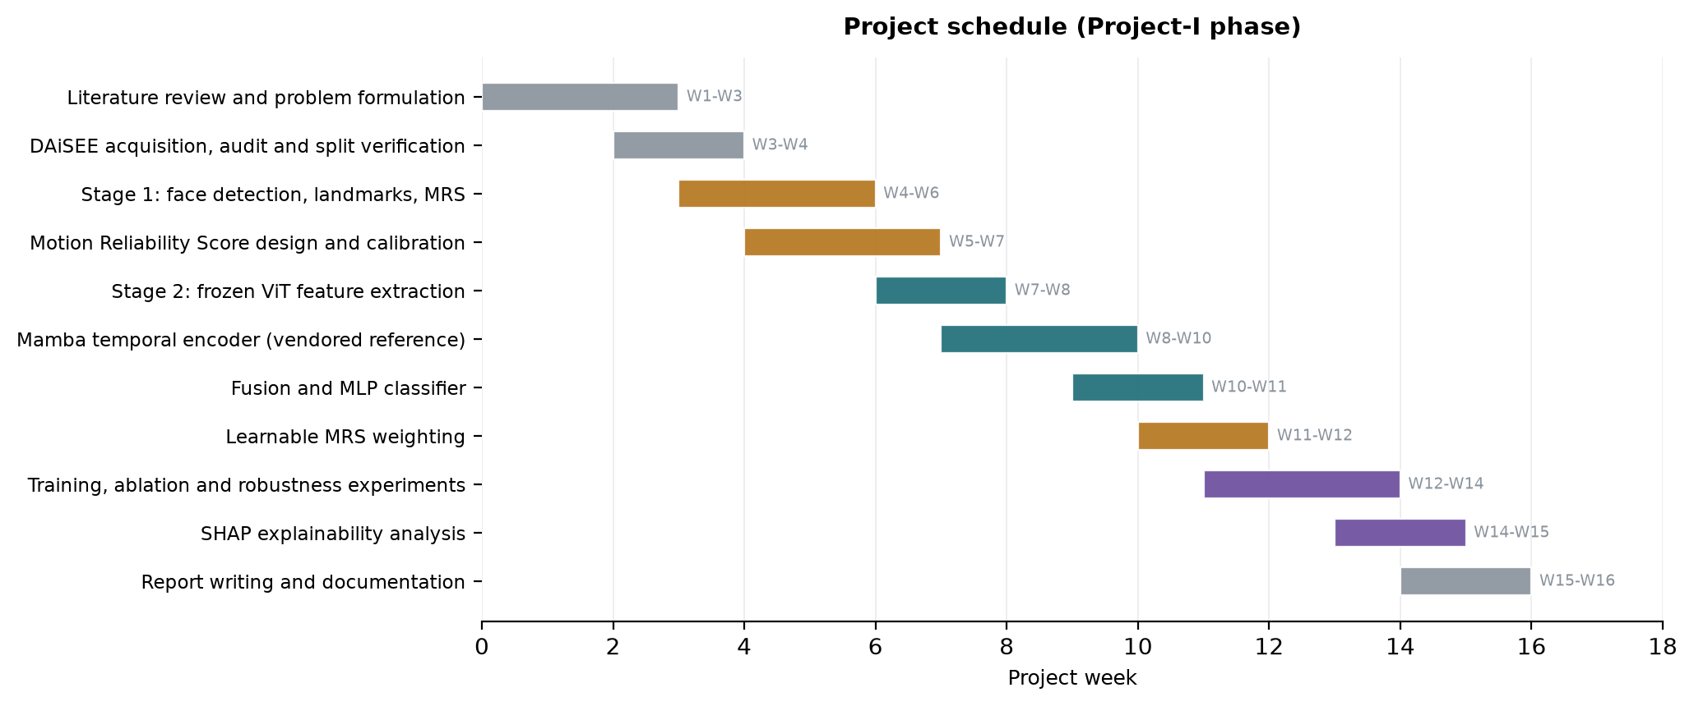
Figure 2.1 Gantt chart for Project-I schedule..

3. TECHNICAL SPECIFICATION

3.1 Requirements

3.1.1 Functional
The functional requirements listed below are classified by pipeline stage and are stated as verifiable obligations of the system.
- Dataset ingestion and auditing (FR-1 to FR-5): The system will detect DAiSEE’s directory structure, read label CSVs from the official source, match videos and labels together, and report back all the labels which do not have videos and vice versa. It will extract probe-decode each video and calculate the actual number of frames, frame rate and duration of the video, rather than make assumptions about them. It will determine the identifier of the participant for each clip and determine the pair-wise subject overlap between training, validation and test datasets, and refuse to go further if any overlap is greater than zero.
- Temporal sampling (FR-6 to FR-8): The system will sample T frames per clip by uniform sampling with T being configurable to {8, 16, 32, 64}, use deterministic sampling instead of randomness to make sure runs are reproducible, and will return exactly T frames for every clip, even if the clip is shorter than T.
- Face processing (FR-9 to FR-12): The system should detect the face of the participant in each sampled frame, rotate the crop using detected eye keypoints, pad and resize the cropped face to backbone input resolution, and record the detector confidence level. In the absence of detected faces, the system should degrade gracefully by following an explicit, recorded cascade of fallbacks and marking the frame as unreliable.
- Reliability scoring (FR-13 to FR-17): The system should calculate five observation-quality scores per frame – blur, face presence, head pose, eye and iris presence, and motion consistency; each score lies in the range of [0,1], the system should combine them into one MRS value, it should tune any dataset-dependent calibration on the training split alone, and ensure that no engagement label is used in computation.
- Feature extraction (FR-18 to FR-21): The system shall obtain the embedding dimension for each aligned crop from the frozen pretrained Vision Transformer instead of having it pre-specified; and shall obtain 478 facial landmarks, 52 blendshapes and a head pose matrix for each frame, transforming them into a fixed-length and normalised feature vector.
- Temporal modelling and classification (FR-22 to FR-26): The system shall use the reliability score to modify the frame embeddings while keeping the same number and temporal positions intact; shall use a Mamba selective state-space encoder to model the modified sequence; shall pool the sequence to form a clip embedding; shall concatenate it to the landmark branch after normalisation and projection; and shall return four raw class logits.
- Learning and evaluation (FR-27 to FR-32): The system will set the reliability weights of the five to 0.20 and modify their values using the gradient descent method in the process of training and save them in the checkpoint to use them later in validating and testing; choose the checkpoint for obtaining the results depending on the macro F1 score obtained from the validation set and not the test set; and provide accuracy, weighted F1, macro F1, per-class values, and a confusion matrix and also SHAP analysis of the fusion.
- Caching and reproducibility (FR-33 to FR-36): The system will cache any expensive preprocessing step with a hash computed over all parameters that may affect the contents of the cache so that an old cache cannot be accidentally used; and include the exact versions of packages used with each result.
3.1.2 Non-Functional
• Accuracy and verifiability: Every step of the pipeline has to have an automated verification step which raises loud exceptions and doesn't fail gracefully. The temporal encoder, in particular, needs to have a causal and numerical check against an independently implemented version of the recurrence relation.
• Prevention of leakage and maintenance of data integrity: None of the statistics used for inference, reliability calibration, feature scaling, or class weights can be trained on validation or test sets and it needs to be structurally enforced, not by convention.
• Performance: Preprocessing of the development set of 216 clips has to be completed in under five minutes on a single consumer GPU, whereas training epochs on the cached features need to be completed in under two seconds, allowing for quick experimentation iterations.
• Scalability: The architecture should scale to the entire 9,068 clips DAiSEE dataset only by configuring it, with the preprocessing being split in a way that changing the visual backbone doesn't require re-computing CPU-intensive landmarks extraction.
• Reproducibility: All random seeds need to be set and all results should cite an artifact file commit rather than the transcript.
• Privacy and licensing: The video, the face crops and the landmarks that come from the DAiSEE dataset are not to be committed to any version control system; neither are the labels.
• Maintainability: The functions for sampling, face detection, reliability score computation, encoding, modeling, fusion and evaluation are to be made modular without any hardcoded paths to the dataset or the tensor dimensions.

3.2 Feasibility Study

3.2.1 Technical Feasibility
- The three pretrained models needed are freely available to download: the Vision Transformer (ViT-B/16), pretrained on ImageNet using the timm module, and two MediaPipe bundles – the BlazeFace Face Detector (230 KB) and the Face Landmarker (3.76 MB), which have been made available by Google.
- The freeze operation on the Vision Transformer model will bring down the number of trainable parameters from about 87 million to 1.37 million. This can be trained easily in the 6 GB memory space of the development GPU.
- An important technical issue was found and addressed during implementation. The official mamba-ssm package is shipped in source form and uses the CUDA Toolkit compiler for building, which was unavailable in the development environment; it failed to install. Instead of using an alternate architecture, the application bundles the official (non-fused) reference implementation provided by the Mamba library, which does the computation without compilation. It is a question of speed and not correctness and the active backend used is documented in every output artifact.
- Using backbone-independent CPU-based preprocessing and GPU-based feature extraction makes the process cost-effective. The visual backbone can be changed at a cost of only the second stage, which is about 27 seconds for the development dataset.

3.2.2 Economic Feasibility
- Cost of software is zero. PyTorch, timm, MediaPipe, OpenCV, scikit-learn and SHAP are all open source, and pretrained weights are available for research purposes.
- Cost of hardware is limited to just one consumer-grade laptop GPU already owned by the team; no cloud computing cost, API cost or annotation budget is needed.
- DAiSEE is available for free research use after registration, therefore there is no cost for data acquisition.
- The biggest cost is student labor. The training process takes less than one minute due to caching features, making experimentation cost almost nonexistent compared to development cost.

3.2.3 Social Feasibility
- Recognition of engagement in relation to students poses ethical concerns. The mechanism is considered to be an aggregation research tool, not a monitoring or assessment tool, and any decision making related to per student is out of question.
- DAiSEE annotations are subjective evaluations of the observable affect by third parties. These annotations should not be treated as objective metrics of the mental state of the learner.
- The dataset consists of videos that contain images of identifiable persons. In connection with this issue, the project team will exclude the video, the cropped faces and landmarks from version control and will consider the per clip labels as non-redistributable.
- The deployment of this approach in practice requires informed consent and ethics review as well as lack of demographic disparity. None of these conditions is met here.

3.3 System Specification

3.3.1 Hardware Specification
Table 3.1 Hardware specification.
Component | Development configuration (used) | Recommended for full DAiSEE
Processor | x86-64, 8 logical cores | 12+ cores (MediaPipe is CPU-bound)
Memory (RAM) | 16 GB | 32 GB
Storage | 60 GB free (SSD) | 250 GB SSD (15 GB dataset + caches)
Graphics Processing Unit | NVIDIA GeForce RTX 3060 Laptop, 6 GB, compute 8.6 | NVIDIA RTX 3090 / A4000, 12-16 GB
Display | 1920 x 1080 | 1920 x 1080 or higher

3.3.2 Software Specification
Table 3.2 Software Specification (version numbers verified on development machine).
Layer | Software | Version
Operating system | Windows 11 Home (64-bit) | 10.0.26200
Language | Python | 3.13.3
Deep learning | PyTorch / torchvision | 2.11.0+cu128 / 0.26.0+cu128
GPU runtime | CUDA (bundled with PyTorch wheel) | 12.8
Vision backbones | timm (PyTorch Image Models) | 1.0.29
Transformer hub | transformers | 5.16.1
Facial analysis | MediaPipe Tasks (Face Detector, Face Landmarker) | 1.0.1
Image processing | OpenCV | 5.0.0
Sequence model | Vendored Mamba reference (state-spaces/mamba) | pytorch_reference
Numerics | NumPy | 2.5.2
Metrics | scikit-learn | 1.9.0
Explainability | SHAP | 0.52.0
Plotting | Matplotlib | 3.11.1
Testing | pytest | 9.1.1

4. DESIGN APPROACH AND DETAILS

4.1 System Architecture
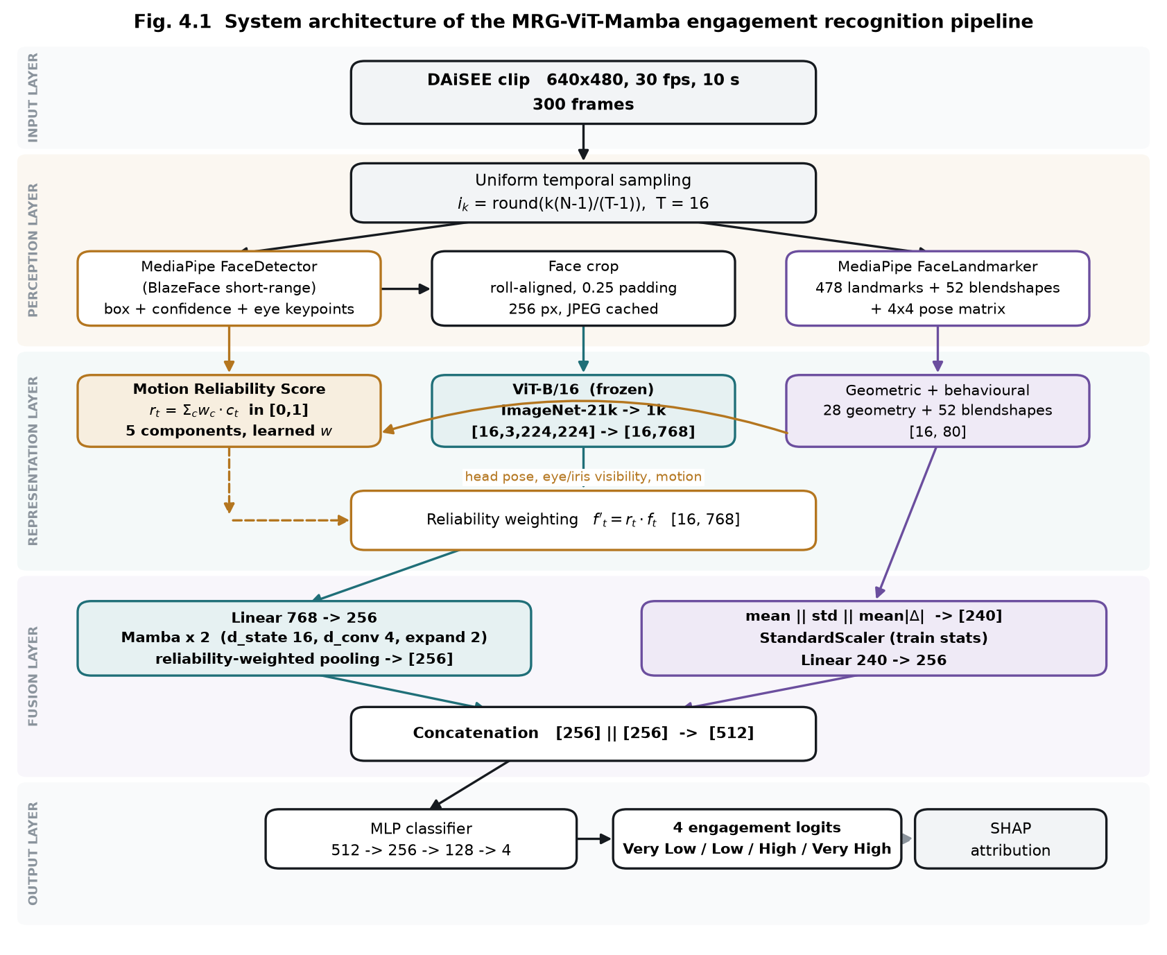
Fig. 4.1 System architecture of the MRG-ViT-Mamba engagement recognition pipeline.
The architecture has been divided into five layers. The first layer receives the DAiSEE data set of 10 seconds, having a resolution of 640 x 480, and 30 frames per second. From there, the perception layer extracts T = 16 frames randomly with the help of indexing i_k = round(k(N-1)/(T-1)). Since sampling is deterministic in nature, the same frames will appear in each execution.
The perception layer performs a series of actions on every sampled frame, using two MediaPipe pretrained models. These are the BlazeFace model for detecting objects in short range with output of bounding box, a confidence score, and six facial keypoints, from where two eye keypoints are used for rolling alignment of the crop. In addition, the Face Landmarker model provides 478 three-dimensional landmark points (including 10 iris points), 52 ARKit blendshape activations, and a 4 x 4 transformation matrix.
The representation layer includes the three parallel pipelines that make up the defining characteristics of the architecture. The Motion Reliability Score takes in five observation quality cues and generates one value per frame. The frozen ViT-B/16 network maps each aligned crop to a 768-dimensional embedding in the form of [B,T,C,H,W] rearranged into [B*T,C,H,W] followed by [B,T,768] all in one pass instead of in a loop of per frame passes. The landmarks pipeline takes in the original mesh and maps it to 28 scale-invariant geometric properties that along with the 52 blendshapes create an 80-dimensional representation per frame. Weighting for reliability then follows as f'_t = r_t * f_t.
The fusion layer projects the reliability-weighted sequence of 768 dimensions down to 256 dimensions and feeds it to two Mamba blocks. Each Mamba block consists of RMSNorm, an input projection, causal depthwise convolution, SiLU activation and the selective scan with a skip connection. Reliability-weighted pooling is used to aggregate the sequence, D = sum_t r_t h_t / sum_t r_t, which is the place where the reliability signal affects the clip representation the most. Meanwhile the frame-wise landmark descriptions are aggregated temporally via concatenation of the mean, standard deviation and mean absolute temporal difference into a 240-dimensional clip vector which is normalised according to training split statistics and projected to 256 dimensions. Both 256-dimensional vectors from the two branches are concatenated into 512.
The output layer is a multilayer perceptron with architecture 512 to 256 to 128 to 4, where GELU activation function is used together with dropout. Four logits are generated by the network and the training procedure uses the class-weighted cross-entropy loss. SHAP attributions are calculated on the fused representation where the landmark half of the representation still has named dimensions and can therefore be grouped into interpretable facial families.

Table 4.1 Parameter budget of the assembled model.
Module | Detail | Parameters | Trained
ViT-B/16 backbone | frozen, preprocessing stage | 85,798,656 | No
Temporal input projection | Linear 768 -> 256 | 196,864 | Yes
Mamba blocks | 2 blocks, d_inner 512, d_state 16 | 876,032 | Yes
Final RMSNorm | 256 | 256 | Yes
Deep branch projection | LayerNorm + Linear 256 -> 256 | 66,304 | Yes
Landmark branch projection | Scaler + Linear 240 -> 256 | 61,696 | Yes
Learnable MRS weights | softmax over 5 components | 5 | Yes
MLP classifier | 512 -> 256 -> 128 -> 4 | 164,740 | Yes
Trainable total |  | 1,365,897
Whole pipeline |  | 87,164,553

4.2 Design

4.2.1 Data Flow Diagram
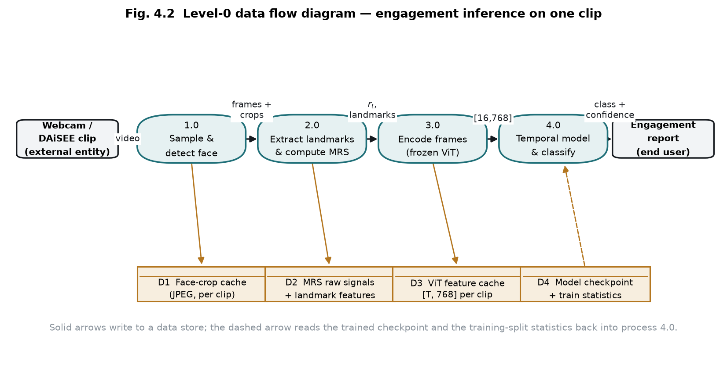
Fig. 4.2 Level-0 data flow diagram for engagement inference on a single clip.
Diagram depicts the flow of a particular clip through the pipeline. The clip arrives at process 1.0, where it is sampled into sixteen frames and face detection, alignment, and cropping is done, and the resulting crops are saved in the data store D1. Process 2.0 extracts landmarks and blendshapes and calculates five raw reliability signals, which are saved to D2 in their uncalibrated version. Unprocessed storage of raw reliability signals is a deliberate choice of design since it means that the reliability calibration can be refitted, and the relative weights of components adjusted without going through the process of redecoding videos. Process 3.0 takes the cached crops and feeds them into frozen Vision Transformer model producing frame-level embeddings, which are saved to D3. Process 4.0 takes the cached embeddings, reliability signals, and landmarks, performs the weighting of the latter, executes the Mamba temporal encoder and the fusion classifier, and outputs engagement prediction with confidence score. The dashed arrow marks the fact that process 4.0 also accesses the trained checkpoint and normalisation statistics of the training split from D4.

4.2.2 Use Case Diagram
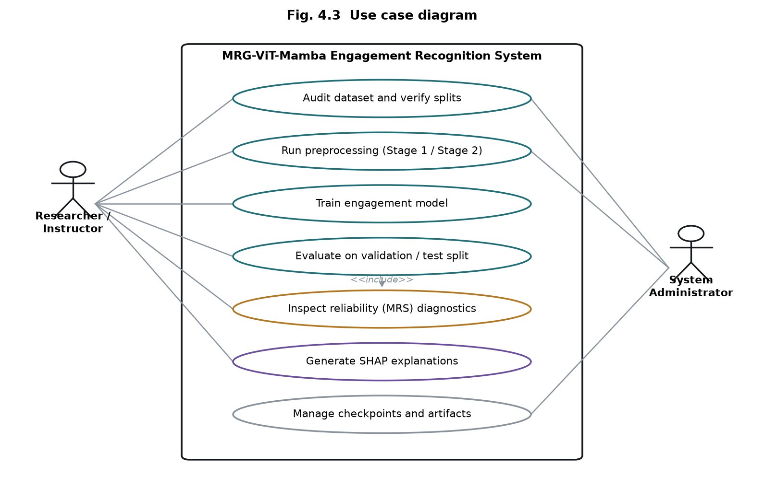
Fig. 4.3 Use case diagram.
There are two agents that participate in the interaction with the system. The researcher or teacher reviews the data set and confirms the split, conducts the two preprocessing steps, trains the model, performs the evaluation on the validation and test data splits, reviews the reliability diagnostics, and performs the SHAP explanation. Evaluation comprises checking of the reliability diagnostics because interpretation of the score on a particular class depends on the visibility of the underlying videos. System administrator includes checkpoint and artifacts management in addition to preprocessing and auditing functions.
4.2.3 Class Diagram
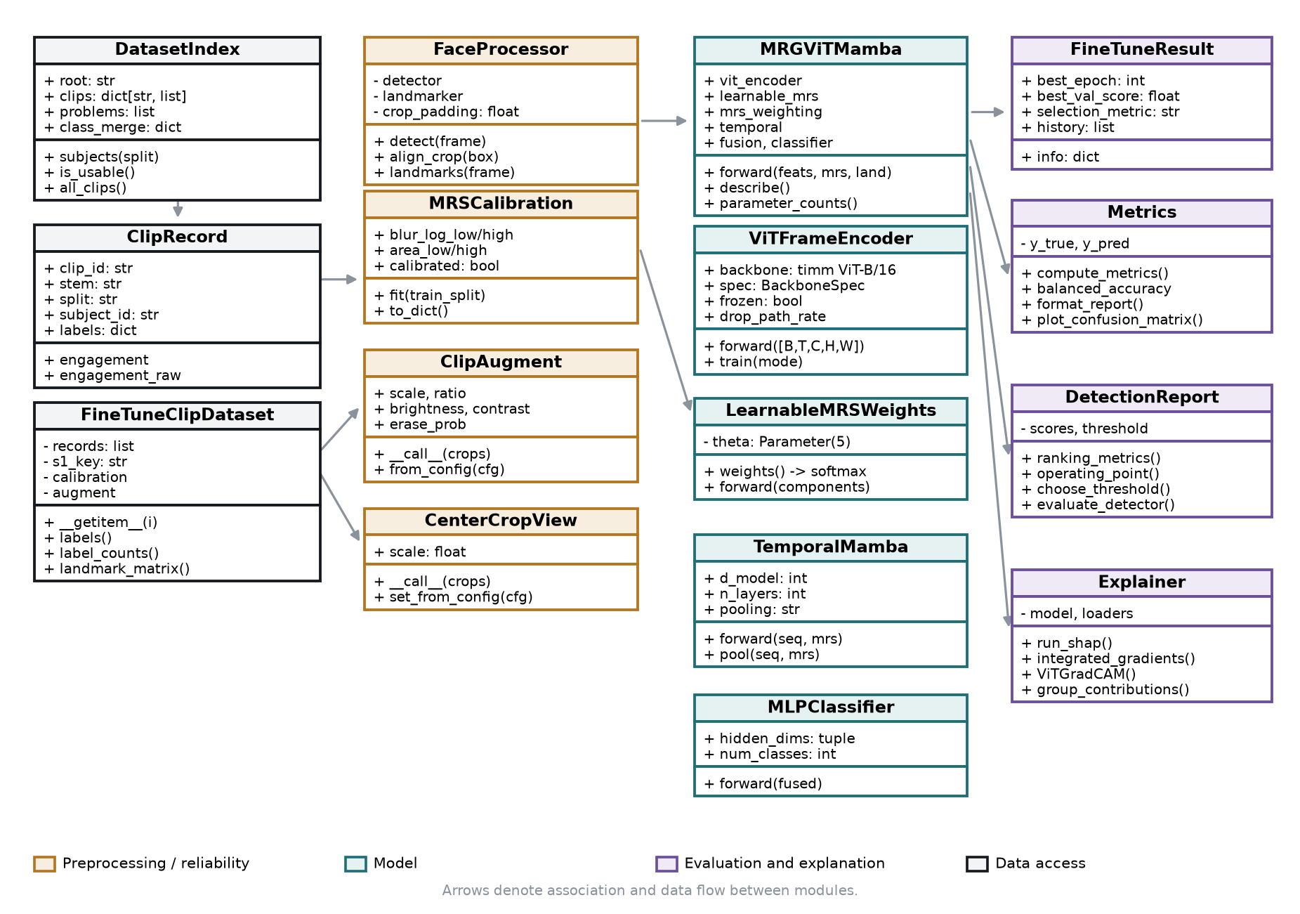
Figure 4.4 Class diagram of the developed system.
The class diagram divides the implementation into four collaborating layers. DatasetIndex implements the data access layer where it finds the DAiSEE tree and matches each ClipRecord with its label row, whereas FineTuneClipDataset implements a cache for providing crops and landmarks to the training loop. FaceProcessor is part of the preprocessing layer alongside two augmentations – ClipAugment for training and CenterCropView for test-time determinism. Moreover, the preprocessing layer holds the percentiles of the MediaPipe models wrapped in FaceProcessor and MRSCalibration. ModelAssembler constructs the model using four components: ViTFrameEncoder, LearnableMRSWeights, TemporalMamba, and MLPClassifier inside MRGViTMamba. FineTuneResult holds the selected checkpoint and history of the fine-tuning process in the evaluation layer, Metrics and DetectionReport calculate reported metrics and their baselines, and Explainer runs the attributions analysis.

4.2.4 Sequence Diagram
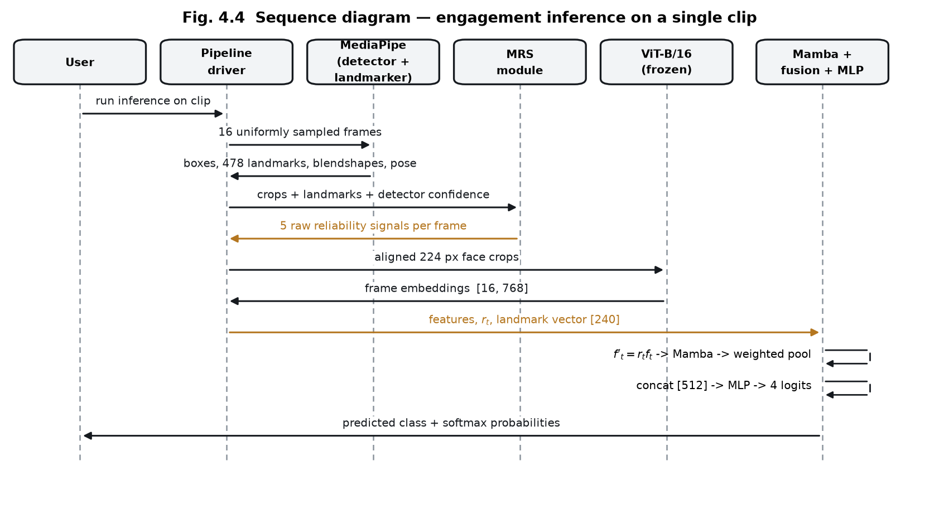
Fig. 4.5 Sequence diagram for engagement inference on one clip.
This sequence represents the order of actions that take place when inferring. The pipeline driver gathers sixteen samples and sends them to the MediaPipe which outputs detector boxes, landmarks, blend shapes, and pose matrices. All of these, along with the aligned crops and detector confidence, are sent to the reliability module that provides five raw signals for each frame. Crops are then encoded using a frozen vision transformer to give a tensor of size [16, 768]. This is followed by the temporal and fusion stage where the embeddings, the reliability vector, and the landmark descriptor go through the weighting process, Mamba encoding, and reliability-weighted pooling to generate four logits.

5. METHODOLOGY AND TESTING
5.1 Module Description
The system is split into nine modules with tight coupling such that any modification in one can be verified independently. The decomposition is done along the lines of how the data flows from raw video to explanation of the prediction.
5.1.1 Dataset indexing and auditing
The indexer component navigates the DAiSEE hierarchy structure and parses all four label CSV files containing labels. The process assumes nothing about the cleanliness of the provided structure: the CSVs have an additional whitespace in the last column header, the ClipID column has the file extension and in one case the extension of the clip mismatches between the CSV and directory tree, hence using the stem instead. The subject ID is obtained from the directory path one directory below the split directory level, which allows the disjointness check of subjects between splits. For the full dataset release the indexer produces 5,357 train, 1,429 validation and 1,784 test clips for 69, 19 and 21 subjects respectively, with no subject overlap between pairs of splits.
5.1.2 Stage 1 preprocessing
Stage 1 samples T frames uniformly from each clip, performs face detection and roll alignment using MediaPipe BlazeFace, extracts 478 landmarks, 52 blendshape coefficients, and a 4x4 head-pose matrix using MediaPipe FaceLandmarker, and stores the aligned JPEG crops and five raw reliability signals into a compressed cache. The cache key contains a digest of all parameters that influence the contents of the cache, such that any change in the frame count or crop size generates a new cache instead of inadvertently recycling an out-of-date one. Evaluated over the whole release with T = 16, this stage operates on 8,570 clips in about fifteen minutes in six concurrent shards, using 1.3 GB of disk space.
5.1.3 Motion Reliability Score
The reliability model transforms the five cached raw signals to calibrated components in the range [0,1], where the components represent: blur as the variance of the Laplacian, face visibility as the size of the bounding box detection and its confidence, head orientation based on the yaw and pitch difference from the frontal position, eye visibility based on the landmark mesh, and movement consistency based on the frame-to-frame distance between landmarks. Calibration of blur and face area is performed based on percentiles calculated only for the training set, hence no statistic calculated during inference was fitted on the validation data. The components are weighted using a weight vector computed as the softmax of five parameters.
5.1.4 Spatial encoder
The encoding for each aligned video is done using the pre-trained ViT-B/16 backbone on ImageNet, giving an embedding size of 768 dimensions per frame. The backbone encoder converts the input batch size of [B, T, C, H, W] to [B x T, C, H, W] just once and then processes it in batches, rather than iterating through all frames in the video in Python. In the final architecture, only the last four out of twelve transformer layers and the last normalization layer are trainable.
5.1.5 Reliability-weighted temporal encoder
The reliability score is used twice in the network. Prior to processing in the temporal encoder, each frame embedding is multiplied by its own reliability. Moreover, the subsequent pooling of frames is done in a reliability weighted average instead of an average. Importantly, neither of those processes involves dropping any frame because the amount and order of temporal positions remains unchanged, thus ensuring that the regular sampling of the state-space model is achieved. The temporal encoder is based on a two-layer Mamba selective state-space model with d_model = 256. Due to the fact that the official CUDA kernel is incompatible with the development machine and requires special compiler tools, the vendored reference implementation is used instead.
5.1.6 Landmark branch and fusion
While one branch computes the means, standard deviations, and mean absolute differences over time for each named feature across all the frames, the other branch takes the average landmark geometry and calculates its 240-dimensional clip descriptor. The standardisation of this branch is trained only on the training set. Both branches are reduced to 256 dimensions each and concatenated to form 512 dimensional feature vector fed to the classifier.
5.1.7 Classifier and loss
The classification model is a multilayer perceptron with GELU activation and dropout. Class imbalance is handled using a separate approach at two levels: the sampling probability of each class, which is done using the weighted sampler, and the penalty of misclassification for each of them, using class weights on the loss function. The two are intentionally separated since used in tandem, they amplify one another, and the former alone makes the rare class sample frequency increase from 4.6% to 27.8%, with the latter bringing it up to 81%.
5.1.8 Evaluation
The evaluation module calculates accuracy, balanced accuracy, macro/weighted F1, precision, recall and F1 by class, and confusion matrix, printing each next to its corresponding baseline. It also calculates ROC-AUC and average precision for the binary classification task and determines an optimal operating point based on the validation split, applying the same threshold to the test split. The latter is only loaded once per run, after the checkpoint is selected.
5.1.9 Explainability
Four approaches are used: SHAP attribution of the fused representation grouped into facial features families, integrated gradients w.r.t. the zero baseline to disentangle contributions of the two branches, Grad-CAM w.r.t. the Vision Transformer to highlight the location on the face which the model focused on, and reliability trace indicating which frames had the highest weight in temporal pooling.
5.2 Testing
The project is tested via an automated test suite that includes 169 tests. The tests are not aimed at making sure that the program is working; they are aimed at making those specific failures that such a pipeline causes without a sound cause a failure with a sound.
Table 5.1 Automated test coverage by concern.
Concern | What the tests pin | Tests
Temporal integrity | Reliability weighting changes values but never the number or order of temporal positions | 18
Leakage prevention | Calibration, feature scaler and class weights are fitted on the training split only; splits stay subject-disjoint | 14
Class merging | The merge partitions every class exactly once, is applied identically to all three splits, and preserves the original label | 24
Reliability weights | Softmax weights cannot collapse onto one component; a real signal still moves them; noise alone leaves them uniform | 12
Sampling | No clip is discarded, epoch length is unchanged, rare classes are lifted, repetition is capped | 10
Prior correction | The correction is identity when priors agree, and never derives its shift from the evaluated split | 22
Detection metrics | A constant predictor scores 0.95 accuracy and detects nothing; a better detector may score lower accuracy | 13
Caching and resumption | Cache keys change when inputs change; interrupted runs resume without repeating or skipping an epoch | 26
Numerical and shape contracts | Dimensions are discovered rather than assumed; scores stay in range; metrics match hand calculation | 30

There are two particular tests worth mentioning because they contain flaws that were found in an existing system and not merely conceived. The first test imposes the constant one-sided pressure for the number of steps taken during a full run on the learned reliability weights and claims that they are bounded; otherwise, without that prior provided by the test, the weights become unbounded. The second test states that there might be a detector with signal reporting a lower accuracy compared to a constant predictor, thus preventing a future update from silently making accuracy the primary measure on a 95/5 split.

6. PROJECT DEMONSTRATION
In this chapter, we illustrate a complete execution of our system using the complete DAiSEE dataset, from raw video to a prediction explanation, and identify all the artifacts created during the process. All figures and paths referenced in this section were generated by this process.
6.1 Execution sequence
Pipeline execution is done from the command line. Locations of dataset, cache, and checkpoint files are provided by environment variables in such a way that the same configuration can be executed in a different machine whose storage layout is different without modifying the tracked file.
export DAISEE_ROOT=D:/DAiSEE
export MRG_CACHE_DIR=C:/mrg_run/cache
export MRG_CHECKPOINT_DIR=C:/mrg_run/checkpoints

python scripts/audit_dataset.py --config configs/config_binary_full.yaml
python scripts/run_preprocessing.py --config configs/config_binary_full.yaml --stage 1
python scripts/fit_mrs_stats.py --config configs/config_binary_full.yaml
python scripts/run_finetune.py --config configs/config_binary_full.yaml \
--run-name fullbin --workers 2 --tta
python scripts/run_shap_finetuned.py --config configs/config_binary_full.yaml \
--run fullbin --split test
python scripts/explain_finetuned.py --config configs/config_binary_full.yaml \
--run fullbin
6.2 Stage outputs
Table 6.1 records what each stage produced in the demonstrated run, with the wall-clock cost measured on the development machine described in section 3.3.
Table 6.1 Pipeline stages, outputs and measured cost.
Stage | Output | Cost
Dataset audit | 8,570 clips indexed, zero subject overlap, 497 videos without label rows excluded | < 1 min
Stage 1 preprocessing | Aligned face crops and reliability signals for 8,570 clips, 1.3 GB cache | 15 min
MRS calibration | Blur and face-area percentiles fitted on 5,357 training clips | 1 min
Training | 7 epochs at 8.6 min/epoch, best checkpoint at epoch 0, early stopping on patience | 60 min
Evaluation | Train, validation and test scored once with three-view test-time augmentation | 20 min
SHAP attribution | 512 test clips explained against 512 background clips | 12 min
Worked examples | Three clips from three participants with Grad-CAM, reliability traces and branch attribution | 4 min

6.3 Inference on a single clip
In order to process an individual ten second sequence, the framework will take sixteen samples, align the face from each sample, calculate the five reliability metrics for each face, encode each face using the Vision Transformer, rescale each embedding based on reliability, pass the series through the Mamba encoder, pool the resulting sequence using the reliability values, fuse the result with the landmark descriptor and output a class probability. The example generated from the demo features a clip that is not engaged with a probability of 0.98, where the average frame reliability was 0.48, with the most important frames being 0, 8 and 13.
6.4 Explanation output
This demonstration generates two figures for population-based explanations and one set of per-clip figures. The first figure 6.1 displays the percentage of contribution attributed to each of the facial feature families using 512 test clips; figure 6.2 displays the confusion matrix for the same set of clips.
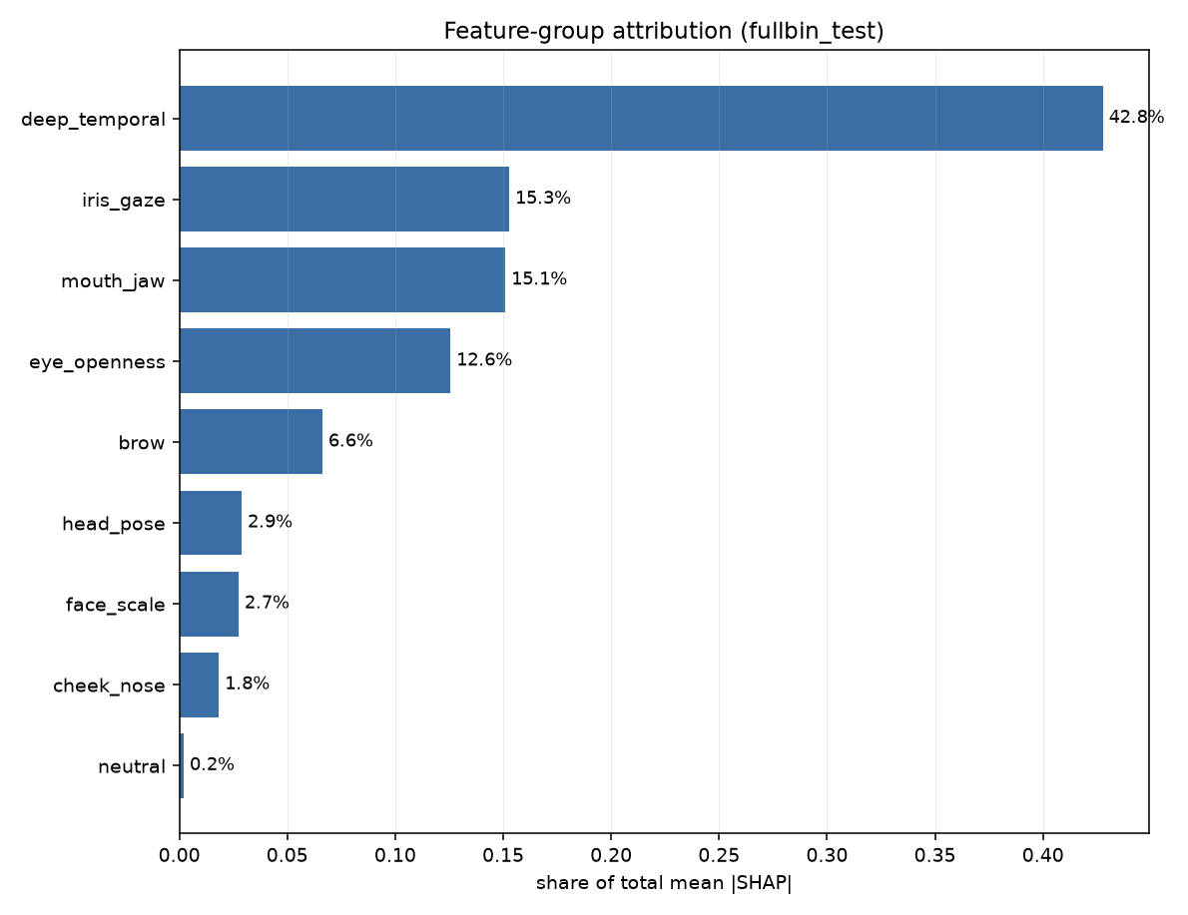
Fig. 6.1 SHAP attribution by facial feature family, 512 test clips.
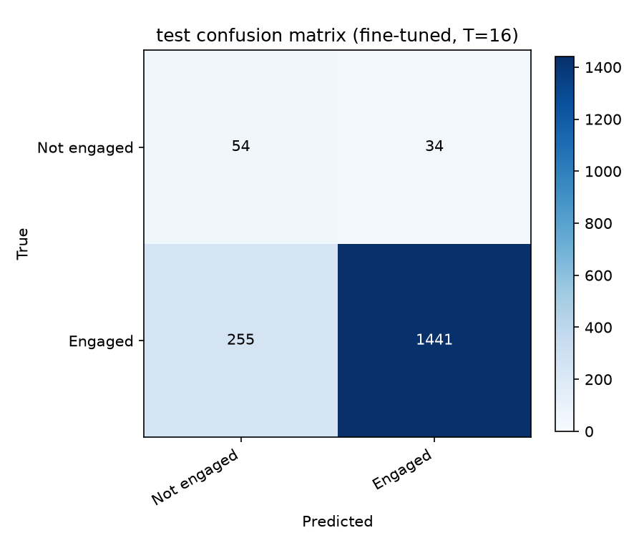
Fig. 6.2 Confusion matrix on the full DAiSEE test split, 1,784 clips.

These individual per-clip data also include a picture of the participant’s face and are therefore output to an excluded directory and not included in this report due to licensing conditions, as outlined in section 3.2.3.

7. RESULT AND DISCUSSION
This chapter describes the successes of the system, its failures, and what the control comparison implies regarding the mechanism proposed for the project. All figures are also accompanied by the baseline that is relevant to the figure, as the distribution of classes on DAiSEE renders many measures meaningless without it.
7.1 Experimental protocol
The official DAiSEE partition is used as-is. Subject disjointness among the three partitions was programmatically verified to hold exactly. Checkpointing is done based on validation balanced accuracy, while the test partition is loaded once per experiment, after checkpointing, and does not affect it in any way. All randomness is seeded. Numbers cited herein come from committed artifact files, not from console outputs.
Two class settings are presented. In the three-class setting, classes of DAiSEE engagement level 0 and 1 are merged, having only 34 and 213 training samples and 4 and 84 test samples respectively; merged class has 247 training samples and 88 test samples. The binary setting classifies subjects to either being engaged or not. The merging does not reduce the bar of accuracy, as the majority class accuracy on test partition is 882/1784 = 0.4944 in both four-class and three-class labelings, since High is the largest class anyway.
7.2 Three-class engagement recognition
Table 7.1 Three-class results on the full DAiSEE test split (1,784 clips).
Metric | Model | Majority baseline | Verdict
Accuracy | 0.4596 | 0.4944 | below baseline
Balanced accuracy | 0.4185 | 0.3333 | above baseline
Macro F1 | 0.3833 | 0.2206 | above baseline
Weighted F1 | 0.4661 | - | -

Table 7.2 Performance for each class in three-class classification test data.
Class | Precision | Recall | F1 | Support
Low (levels 0-1) | 0.137 | 0.330 | 0.193 | 88
High (level 2) | 0.511 | 0.546 | 0.528 | 882
Very High (level 3) | 0.491 | 0.380 | 0.428 | 814

It outperforms the majority baseline in terms of balanced accuracy and macro F1 but underperforms it in terms of accuracy. These two claims are both correct, and they evaluate different aspects of the performance, because a constant predictor of the High class obtains 0.4944 accuracy, 0.3333 balanced accuracy, and 0.2206 macro F1. It sacrifices majority precision in favor of minority recall.
7.2.1 Why the accuracy cannot be increased anymore in this formulation
The confusion matrix clearly shows where this mistake happens. Out of 1,696 clips classified as High or Very High, 308 clips that truly belong to class High were assigned the label of Very High and 414 clips that truly belong to Very High were assigned label High. Forcing model to make prediction on these two classes only leads to 0.5153 accuracy and ROC-AUC of 0.5235 (with 0.5 meaning absence of any signal), compared to 0.5200 when model predicts everything as High.
Since two considered classes comprise about 95% of samples in test dataset, it sets the upper limit on accuracy that can be achieved. Three different ways of making decision using already computed probabilities of belonging to these classes also proves this: adjusting for class-weighted loss function increases accuracy to 0.4849, suppressing the rarer class increases it to 0.4899, but still not enough to overcome the baseline of 0.4944. None of possible loss functions, samplers or thresholds helps to improve accuracy, as this is a result of the absence of a signal in the distinction between these classes, regardless of architecture used.
7.3 Binary disengagement detection
When phrased as the detection of disengagement, however, the exact same framework delivers a useful result. The accuracy of the model is provided, but not highlighted; the test split contains 1,696 engaged and 88 not-engaged videos, so the score for a constant “engaged” prediction is 0.9507 with zero detection. The ROC-AUC score is free of threshold selection and class imbalance, and is thus the key metric.
Table 7.3 Binary detection results on the full DAiSEE test split.
Metric | Model | Baseline | Interpretation
ROC-AUC | 0.7943 | 0.5000 | clear signal
Average precision | 0.2628 | 0.0493 | 5.3x baseline
Balanced accuracy | 0.7316 | 0.5000 | above baseline
Accuracy | 0.8380 | 0.9507 | below baseline, as expected
Recall (not engaged) | 0.614 | 0.000 | 54 of 88 found
Precision (not engaged) | 0.175 | - | 255 false alarms

The detector manages to detect 54 out of 88 disengaged videos in the test split with the cost of 255 false positives out of 1,696 engaged videos. Training on the complete dataset versus using only 1,500 videos increased ROC-AUC from 0.7324 to 0.7943, and is aligned with the minority class number being the constraining factor; the smaller dataset contained 69 not-engaged videos vs 247 in the larger one.
7.4 Ablation: does reliability weighting contribute?
The main proposition of the research is the use of observation reliability as weights for frames leading to improved recognition performance. This proposition needs to be verified using a control group – the same model but without the mechanism used and based on the same clips with the same seed. The following two configurations have been compared, differing in two of 117 parameters.
Table 7.4 Ablation study in the complete DAiSEE split.
Configuration | ROC-AUC | Avg precision | Balanced accuracy
Full model, reliability weighting on | 0.7943 | 0.2628 | 0.7316
Control, reliability weighting removed | 0.7941 | 0.2627 | 0.7313
Difference | +0.0002 | +0.0001 | +0.0003

The difference was 0.0002 ROC-AUC, to the fourth decimal place, and on the validation split, the control was slightly better. The bottom line is that, when done as above, reliability weighting did not improve recognition significantly on this data set.
A previous ablation over seven architectural variants, five seeds each, was conducted on a development subset of 120 clips, where the full architecture achieved a test macro F1 score of 0.214 +/- 0.024 compared to 0.205 +/- 0.029 for the ablated architecture without reliability. In this experiment, the question could not be answered: the difference was 0.0090 and the seed-to-seed standard deviation was 0.0266, which meant that the smallest difference five seeds could distinguish as significant would be 0.0388, more than four times larger than the effect size seen. Detecting an effect of 0.0090 at 80% power would require about 137 seeds per arm. The large-scale test in Table 7.4 answers the question that the small-scale one could not.
There is one problem with the test that must be noted. Both the arms chose their optimal checkpoint at the start, and during the seven epochs of training, the learned reliability weights ranged only from 0.182 to 0.218 from their uniform initialization value of 0.200. Thus, the test is really testing reliability weighting with almost uniform weights versus no weighting at all; the learned part of the contribution has not been disproved but rather has been unable to travel far enough due to overfitting.
7.5 Reliability weight stability
A silent and general bug observed during the complete training should be mentioned since when using softmax for the five component weights, with no regularisation, they tend to collapse: after a fifteen epoch run the motion consistency component is 0.990 and the other four are close to 0.001. A five components reliability score becomes a one-component score without any error message and any warning.
Simulations on an equal number of optimiser steps have demonstrated that the learning rate is not responsible for this effect – even when the learning rate is 0.002 and there is no decay, the maximum component weight is still 0.999 – whereas the weight decay is the parameter controlling this effect, since the point with zero in parameter space is exactly uniform weights. The results of the simulations are reported in Table 7.5.
Table 7.5 Simulated maximum component weight after a full run.
Learning rate | Weight decay | Maximum weight reached
0.04 | 0.0 | 1.000 (the observed failure)
0.002 | 0.0 | 0.999 (lowering the rate does not help)
0.002 | 0.5 | 0.902
0.01 | 1.0 | 0.649 (bounded)

The prior is not simply a means of freezing the weight: even with a very weak signal, one component will separate to around 0.30 compared with 0.17 for the other four components; in the case of noise only, all five components are set to 0.20. With the prior applied, three further epochs were run, and each time all five components were in the range 0.182 to 0.218.
7.6 Explainability results
Attribution by SHAP with respect to the fused representation was performed on 512 test clips using 512 background clips. The total per group is a sum over groups of various sizes; hence the per dimension column should be considered.
Table 7.6 SHAP attribution by feature group, 512 test clips.
Feature group | Dimensions | Share of total | Per dimension
Deep temporal (ViT to Mamba) | 256 | 42.77% | 0.00257
Iris and gaze | 45 | 15.28% | 0.00523
Mouth and jaw | 90 | 15.10% | 0.00258
Eye openness | 36 | 12.56% | 0.00537
Brow | 27 | 6.62% | 0.00378
Head pose | 15 | 2.89% | 0.00297
Face scale | 9 | 2.74% | 0.00469
Cheek and nose | 15 | 1.83% | 0.00188

The two eye parameters and the iris/gaze parameters have almost double the weight attributed to the deep temporal parameters per dimension. The high total weight of the deep parameters is primarily because of their higher number of dimensions than that of all other landmark groups put together at 256 and 240, respectively. All top five features ranked are related to eyes: brow lowering, aspect ratio of eyes, eye openness for both eyes, gaze and blink.
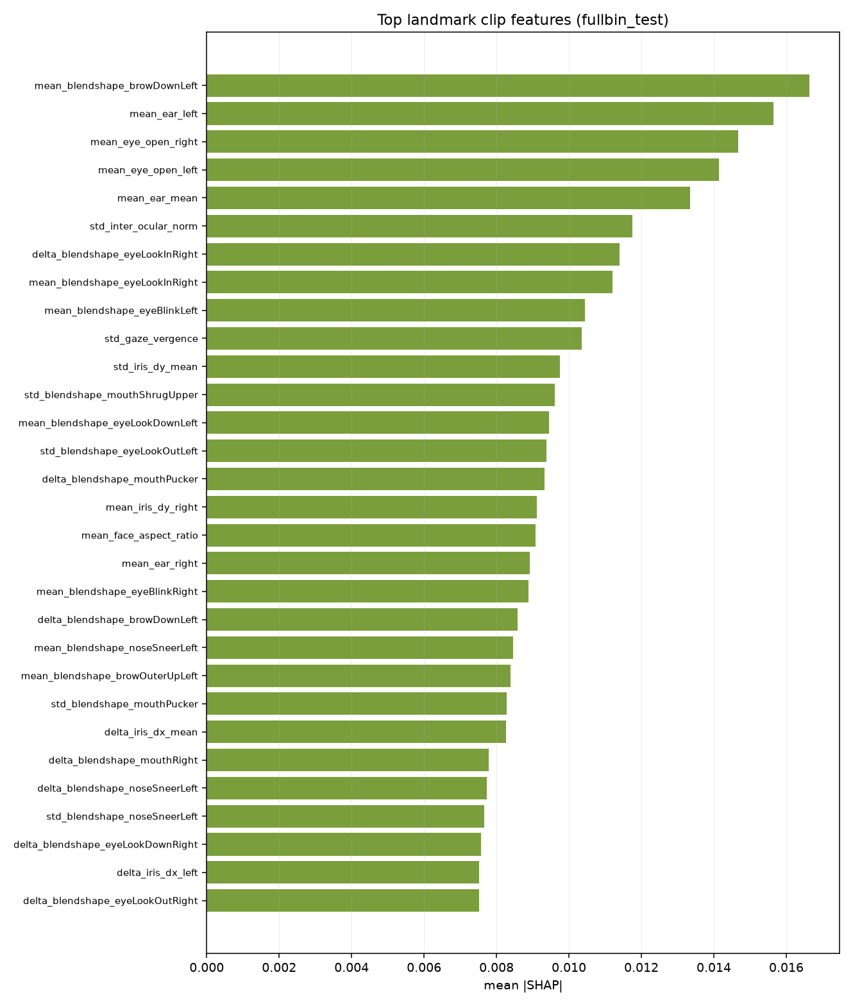
Fig. 7.1 Top named landmark features by mean absolute SHAP value.
Integrated gradients for single clips are also consistent with this conclusion, subject to one important modification. In the three test cases, the landmark branch contributed a score boost of +2.14, +1.51, and +1.56 to the predicted class score, while the deep branch scored a negative contribution of -0.35, -0.14, and +0.12. In addition to the SHAP score, it can be concluded that the deep block contributes similar attribution, but not always towards the correct class.
7.7 Discussion
Three findings follow from the results above, and they are not all favourable to the hypothesis the project set out to test.
•First, the architecture delivers an actual disengagement detection system. ROC-AUC 0.7943 against the 0.5 no-signal baseline, with average precision 5.3 times that of the baseline, on the dataset with 95% of clips belonging to one class.
•Second, the reliability mechanism does not factor into it. The controlled ablation estimates its contribution to be 0.0002 ROC-AUC, and the SHAP shows that the discriminative signal comes from the MediaPipe eye and gaze geometry, and not from the weighted deep representation.
•Third, the four-class formulation is constrained by the ambiguity of the annotation rather than the capabilities of the model. ROC-AUC 0.5235 differentiates between High and Very High engagement, with these two classes constituting 95% of the test set, and therefore no decision rule could increase the accuracy beyond the 0.4944 prior probability.
The research thus does not claim any improvement in the accuracy compared to the literature. The defendable contributions are the collapse result for the reliability-weight scheme and its solution, the length-preserving treatment of reliability as a weight rather than a gate, the controlled ablation which estimates the contribution of the mechanism, and the explainability analysis showing the source of the discriminative signal.

8. CONCLUSION
The experiment in this work sought to verify whether considering the reliability of observations as a length-preserving weight with the weight determined rather than assumed increases engagement detection from webcam videos. The project provided a comprehensive and validated approach for the complete DAiSEE dataset, solving the question, albeit not in the expected way.
8.1 Summary of work
A nine-layered pipeline was developed that has 169 automated test cases. The official DAiSEE dataset split is used as is, and subject disjointness is checked programmatically. A five-factor Motion Reliability Score is computed only using observation quality data based on the training data set and weighted using values from uniform initialization. The score is assigned to frame features and temporal features without discarding any frame. MediaPipe geometry branch is concatenated with the deep temporal branch and the output is compared with explicit baselines with the help of four attribution techniques.
8.2 Findings
- Using the binary detector of disengagement on the whole test set, the system achieves ROC-AUC 0.7943 against a 0.5 baseline and average precision 0.2628 against a 0.0493 baseline, finding 54 of 88 disengaged sequences.
- Conducting an ablation study with two out of 117 settings, we establish that the contribution of reliability weighting is 0.0002 ROC-AUC. The mechanism does not noticeably boost recognition on the dataset.
- The parameters of component weights softmaxed on a long run converge to just one component. Weight decay, not the learning rate, controls them, as zero values in the parameters correspond to the same uniform weighting.
- SHAP values on 512 test samples suggest that eye openness and gaze features have about twice the per-dimension impact compared to the entire deep temporal block, and the top 5 features are all eye-related.
- The Very High versus High separation threshold has ROC-AUC 0.5235, and thus it guarantees that four-class accuracy is bounded by the majority class probability regardless of the decision procedure.
8.3 Limitations
- Single seed results. The full scale experiments show one experiment per setup. The development-scale ablation yielded a standard deviation of 0.0266 for seed to seed variation in macro F1 score, meaning that any difference below 0.04 is not distinguishable without repetition of the seeds.
- The learned-weights hypothesis remains untested rather than being rejected. Both the ablation setups reached the maximum at epoch 0, by which time the five weights only varied between 0.200 and 0.182 to 0.218, and thus the comparison tests uniform weight vs no weight setup.
- No experiment comparing to an external publication was run on this setup. The DAiSEE published figures utilize different splits, evaluation granularities, and class formulations, and therefore are not comparable to the current results.
- DAiSEE data involves adult subjects learning e-courses. Nothing presented here applies to other age groups or recording situations without further validation.
8.4 Future work
- Provide a fair evaluation for the learned weights by freezing the backbone network and training on pre-computed features, where an epoch takes seconds, not minutes, thereby enabling the hundreds of epochs and several seeds needed for the five weights to evolve, as well as a sweep of the decay strength parameter bounding them.
- Utilize the three unused affect labels. DAiSEE provides annotations for boredom, confusion and frustration in addition to engagement, and boredom in particular is a near opposite of the desired task. Multi-task learning will provide quadruple as much supervision per clip without any extra data.
- Consider the levels as ordinal, not categorical. Engagement is ordinal, and thus ordinal regression will focus on the boundary between adjacent classes, just like the current model does, although accidentally, since it is at random there. This will also produce the mean absolute error, root mean squared error and Pearson correlation score.
- Normalize features at the subject level. Engagement is evaluated relative to the baseline of the subject, and normalization is a common and even necessary improvement for affect recognition.
- Since the signal attribution depends on eye and gaze geometry, assess a landmark-only architecture of several hundred thousand parameters versus the current architecture of 87 million parameters. In the event of equivalence, the smaller model wins.
8.5 Final remark
The hypothesis which this project set out to prove was not proven by the results it generated. This was determined via a controlled experiment, rather than deduced from a singular score, and is reported above with the baselines, the effect size and the statistical power listed. A negative result generated like this is more valuable to further research than an unsupported positive one, and the reliability-weight collapse that was observed is an issue which would repeat itself in any system utilizing a softmax for mixture weight parametrization.

9. REFERENCES
[1] A. Gupta, A. D'Cunha, K. Awasthi, and V. Balasubramanian, “DAiSEE: Towards user engagement recognition in the wild,” arXiv:1609.01885, 2016.
[2] J. Whitehill, Z. Serpell, Y.-C. Lin, A. Foster, and J. R. Movellan, “The faces of engagement: Automatic recognition of student engagement from facial expressions,” IEEE Transactions on Affective Computing, vol. 5, no. 1, pp. 86–98, 2014.
[3] O. Sumer, P. Goldberg, S. D'Mello, P. Gerjets, U. Trautwein, and E. Kasneci, “Multimodal engagement analysis from facial videos in the classroom,” IEEE Transactions on Affective Computing, vol. 14, no. 2, pp. 1012–1027, 2023.
[4] J. Donahue, L. A. Hendricks, S. Guadarrama, M. Rohrbach, S. Venugopalan, K. Saenko, and T. Darrell, “Long-term recurrent convolutional networks for visual recognition and description,” in Proc. IEEE CVPR, 2015, pp. 2625–2634.
[5] D. Tran, L. Bourdev, R. Fergus, L. Torresani, and M. Paluri, “Learning spatiotemporal features with 3D convolutional networks,” in Proc. IEEE ICCV, 2015, pp. 4489–4497.
[6] G. Bertasius, H. Wang, and L. Torresani, “Is space-time attention all you need for video understanding?,” in Proc. ICML, 2021, pp. 813–824.
[7] A. Gu and T. Dao, “Mamba: Linear-time sequence modeling with selective state spaces,” arXiv:2312.00752, 2023.
[8] L. Zhu, B. Liao, Q. Zhang, X. Wang, W. Liu, and X. Wang, “Vision Mamba: Efficient visual representation learning with bidirectional state space model,” in Proc. ICML, 2024.
[9] “MC-MIFA: A multi-scale contrastive framework with mutual information for student engagement recognition,” PMC13328615, 2025.
[10] C. Lugaresi, J. Tang, H. Nash, C. McClanahan, E. Uboweja, M. Hays, F. Zhang, C.-L. Chang, M. G. Yong, J. Lee, W.-T. Chang, W. Hua, M. Georg, and M. Grundmann, “MediaPipe: A framework for building perception pipelines,” arXiv:1906.08172, 2019.
[11] A. Ablavatski, A. Vakunov, I. Grishchenko, K. Raveendran, and M. Zhdanovich, “Real-time Pupil Tracking from Monocular Video for Digital Puppetry,” arXiv:2006.11341, 2020.
[12] Y. Kartynnik, A. Ablavatski, I. Grishchenko, and M. Grundmann, “Real-time facial surface geometry from monocular video on mobile GPUs,” in Proc. CVPR Workshops, 2019.
[13] P. Ekman and W. V. Friesen, Facial Action Coding System: A Technique for the Measurement of Facial Movement. Palo Alto, CA: Consulting Psychologists Press, 1978.
[14] T. Soukupová and J. Čech, “Real-time eye blink detection using facial landmarks,” in Proc. 21st Computer Vision Winter Workshop, 2016.
[15] J. L. Pech-Pacheco, G. Cristóbal, J. Chamorro-Martínez, and J. Fernández-Valdivia, “Diatom autofocusing in brightfield microscopy: A comparative study,” in Proc. 15th Int. Conf. Pattern Recognition, 2000, pp. 314–317.
[16] F. Crete, T. Dolmiere, P. Ladret, and M. Nicolas, “The blur effect: Perception and estimation with a new no-reference perceptual blur metric,” in Proc. SPIE Human Vision and Electronic Imaging XII, vol. 6492, 2007.
[17] P. Terhörst, J. N. Kolf, N. Damer, F. Kirchbuchner, and A. Kuijper, “SER-FIQ: Unsupervised estimation of face image quality based on stochastic embedding robustness,” in Proc. IEEE CVPR, 2020, pp. 5651–5660.
[18] A. Kendall and Y. Gal, “What uncertainties do we need in Bayesian deep learning for computer vision?,” in Proc. NeurIPS, 2017, pp. 5574–5584.
[19] J. Yang, P. Ren, D. Zhang, D. Chen, F. Wen, H. Li, and G. Hua, “Neural aggregation network for video face recognition,” in Proc. IEEE CVPR, 2017, pp. 4362–4371.
[20] S. M. Lundberg and S.-I. Lee, “A unified approach to interpreting model predictions,” in Proc. NeurIPS, 2017, pp. 4765–4774.
[21] A. Dosovitskiy, L. Beyer, A. Kolesnikov, D. Weissenborn, X. Zhai, T. Unterthiner, M. Dehghani, M. Minderer, G. Heigold, S. Gelly, J. Uszkoreit, and N. Houlsby, “An image is worth 16x16 words: Transformers for image recognition at scale,” in Proc. ICLR, 2021.
[22] A. Steiner, A. Kolesnikov, X. Zhai, R. Wightman, J. Uszkoreit, and L. Beyer, “How to train your ViT? Data, augmentation, and regularization in vision transformers,” Transactions on Machine Learning Research, 2022.
[23] Y. Cui, M. Jia, T.-Y. Lin, Y. Song, and S. Belongie, “Class-balanced loss based on effective number of samples,” in Proc. IEEE CVPR, 2019, pp. 9268–9277.
[24] V. Bazarevsky, Y. Kartynnik, A. Vakunov, K. Raveendran, and M. Grundmann, “BlazeFace: Sub-millisecond neural face detection on mobile GPUs,” arXiv:1907.05047, 2019.
[25] I. Loshchilov and F. Hutter, “Decoupled weight decay regularization,” in Proc. ICLR, 2019.

Web resources:
DAiSEE dataset - https://people.iith.ac.in/vineethnb/resources/daisee/
Mamba reference implementation - https://github.com/state-spaces/mamba
Vision Mamba (Vim) - https://github.com/hustvl/Vim
MediaPipe Solutions - https://ai.google.dev/edge/mediapipe/solutions/guide
PyTorch Image Models (timm) - https://github.com/huggingface/pytorch-image-models

APPENDIX A - SAMPLE CODE
Four segments are copied: the reliability ensemble, the length-preserving weight, the prior that constrains the weights being learned, and the detector used to make accuracy readable on an imbalanced split. The full code is organized as discussed in section 5.1.
A.1 Combining the five reliability components
COMPONENTS = ("blur", "face_visibility", "head_pose",
"eye_visibility", "motion_consistency")

def mrs_from_arrays(blur_raw, face_area_fraction, detector_confidence,
head_pose_deg, eye_visibility, motion_consistency,
cfg_mrs, calibration):
"""[T] raw arrays -> reliability score [T] in [0, 1]."""
weights = cfg_mrs["weights"]
total_w = sum(float(weights[c]) for c in COMPONENTS)
parts = components_from_arrays(blur_raw, face_area_fraction,
detector_confidence, head_pose_deg,
eye_visibility, motion_consistency,
cfg_mrs, calibration)
mrs = sum(float(weights[c]) * parts[c] for c in COMPONENTS) / total_w
return np.clip(mrs, 0.0, 1.0).astype(np.float32)
A.2 Learned weights as a softmax over five parameters
class LearnableMRSWeights(nn.Module):
"""w = softmax(theta); theta = 0 is exactly the uniform 0.2 weighting,
which is why weight decay on theta is a prior toward uniform."""

def __init__(self, n_components: int = 5):
super().__init__()
self.theta = nn.Parameter(torch.zeros(n_components))

def weights(self) -> torch.Tensor:
return torch.softmax(self.theta, dim=0)

def forward(self, components: torch.Tensor) -> torch.Tensor:
# components [B, T, 5] -> reliability [B, T]
return (components * self.weights()).sum(dim=-1).clamp(0.0, 1.0)
A.3 Reliability as a weight but not as a gate
def forward(self, vit_features, mrs, landmark_features=None,
mrs_components=None):
# Recompute the score from components so the combination is in
# the graph and the five weights receive gradient.
if self.learnable_mrs is not None and mrs_components is not None:
mrs = self.learnable_mrs(mrs_components)

# Scale every frame; drop none. The temporal positions and their
# ordering are preserved, so the state-space model still sees a
# regularly sampled sequence.
weighted = self.mrs_weighting(vit_features, mrs)
sequence, pooled = self.temporal(weighted, mrs)

deep = self.deep_branch(pooled)
land = self.landmark_branch(landmark_features) if self.use_landmarks else None
return self.classifier(self.fusion(deep, land))
A.4 Metrics to detect in a 95/5 split
def evaluate_detector(y_true, probs, tune_on=None,
objective="balanced_accuracy"):
"""Accuracy is not the headline here: a constant 'engaged' answer
scores 0.9507 while detecting nothing, so a BETTER detector often
reports a LOWER accuracy. ROC-AUC leads; the operating point is
chosen on validation and applied unchanged to test."""
scores = detection_scores(probs)
out = {"ranking": ranking_metrics(y_true, scores),
"argmax": operating_point(y_true, scores, 0.5)}
if tune_on is not None:
v_true, v_probs = tune_on
chosen = choose_threshold(v_true, detection_scores(v_probs), objective)
out["tuned"] = operating_point(y_true, scores, chosen["threshold"])
out["tuned"]["threshold_chosen_on"] = "validation split"
return out

